1. What is our independent variable? What is our dependent variable?
Dependent Variable: Time taken to name the color
Independent Variable: Colors, Words, Personality, Age, Sex

2. What is an appropriate set of hypotheses for this task? What kind of statistical test do you expect to perform? Justify your choices.
H0 : Null Hypothesis for Congruent condition: Time taken to name the color will not change by increasing or decreasing the randomness of the sequence of the color and words.
Ha : Time taken to name color would increase by increasing the randomness of the colors and word getting displayed.

3. Report some descriptive statistics regarding this dataset. Include at least one measure of central tendency and at least one measure of variability.
Congruent descriptive statistics: Mean: 14.051125, SD: 3.484415713
Incongruent descriptive statistics: Mean: 22.01591667, SD: 4.696055135

4. Provide one or two visualizations that show the distribution of the sample data. Write one or two sentences noting what you observe about the plot or plots.

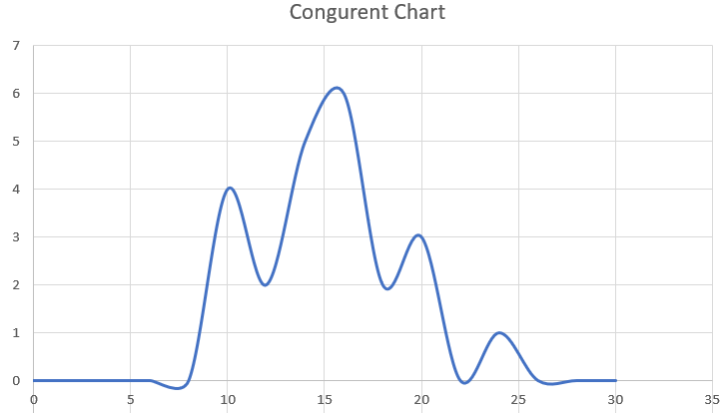
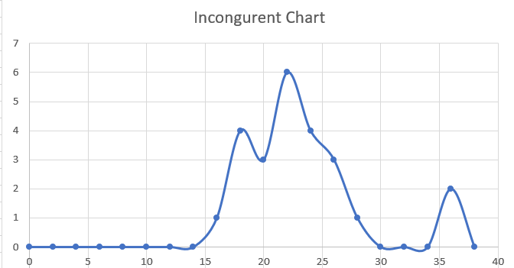

Congruent Chart : Most of the values is between 10 t0 18 and also have small percentage of out layer value such as 24.
Incongruent Chart: The 2 values between 34 and 35 seems to be the out layers.

5. Now, perform the statistical test and report your results. What is your confidence level and your critical statistic value? Do you reject the null hypothesis or fail to reject it? Come to a conclusion in terms of the experiment task. Did the results match up with your expectations?
Congruent Chart: 95% Confidence Interval would fall between 12.65706838 and 15.44518162
H0 : Null Hypothesis for Congruent condition: Time taken to name the color will not change by increasing or decreasing the randomness of the sequence of the color and words.
In another test by increasing the randomness and sequence of color, the sample mean was 15 and the Z-Score was 0.27 and proportion was 0.393.
H0 Conclusion: By looking into the chart and experiment, I agree with the Null Hypothesis that the time taken to name the color have not changed by increasing the randomness of the sequence of the colors and words

